## Adding a Lane Status Sign to your Multi Message Marker

You can also add a Lane Status sign to your Multi Message sign in the 600x600 size for two lanes, or 1200x600 size for four lanes.

**Adding a Lane Status to you Multi Message sign:**

* Select the desired size depending on number of lanes.
* Select the Lane Status Icon (see below).
* You will be directed to select a Lane Status Arrow for each lane.
* Select **Save** and complete your Multi Message Sign and select **Create**.
* 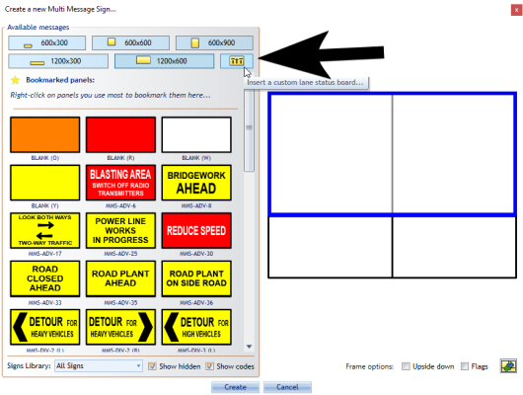
* Adding_a_1200x600_Lane_Status_Sign_to_the_Multi_Message_Sign
* 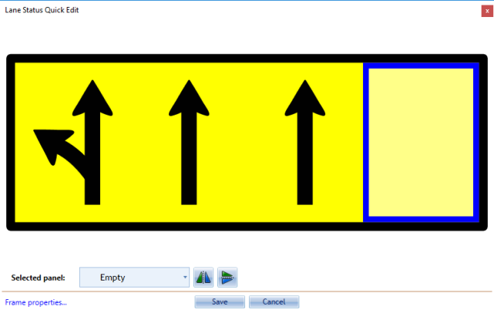
* Setting_the_Four_Lane_Statuses
* 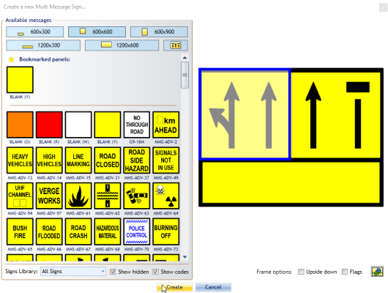
* Creating_the_Lane_Status_Multi_Message_Board